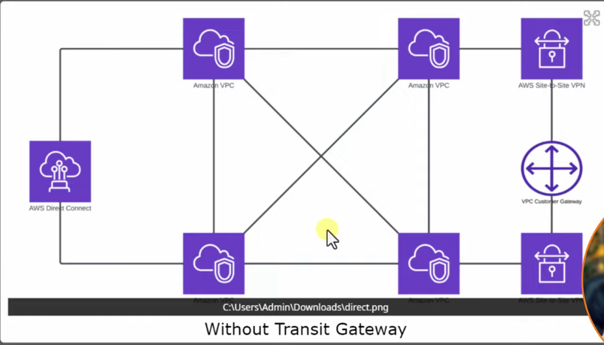
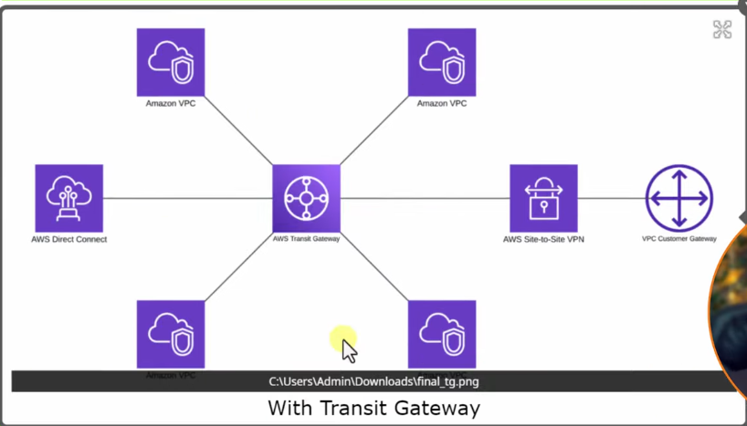
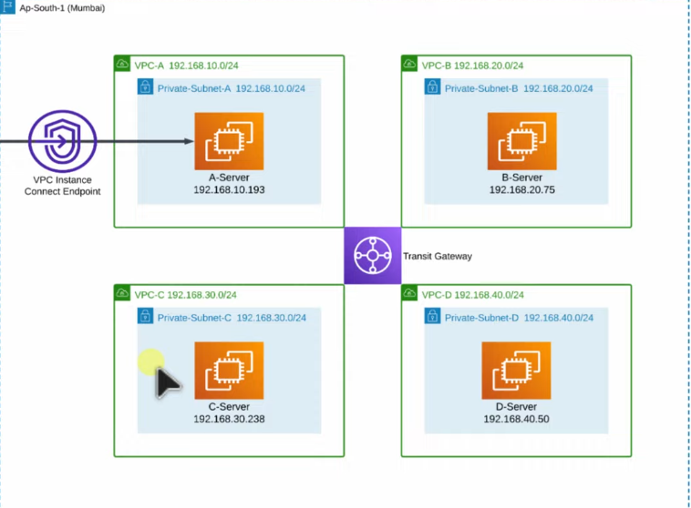
- Create 4 different vpc’s as per digram
- Create 4 different private subnets
- Create private Amazon-linux ec2 instance with no public ipv4 address with Security Group all traffic allow
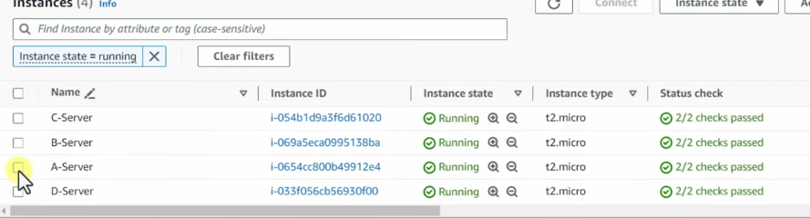
# Create endpoint : go to vpc dashboard and click endpoint
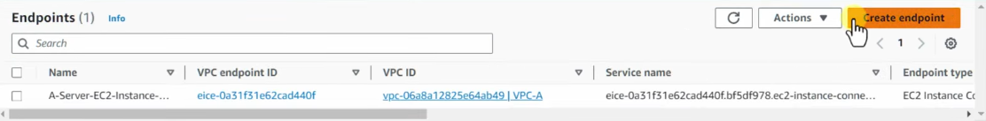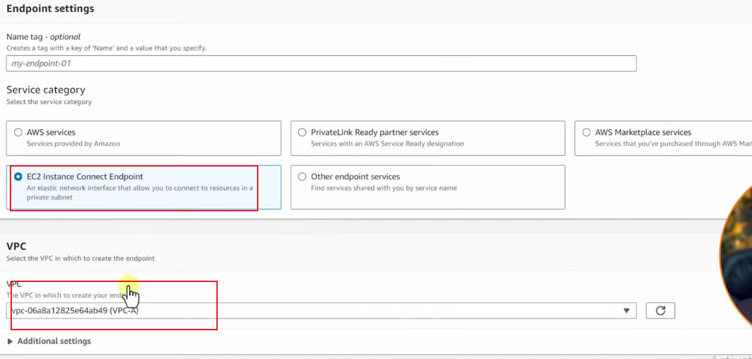
1:Select ec2 connect endpoint , 2: select created vpc’s eg. Vpc-A
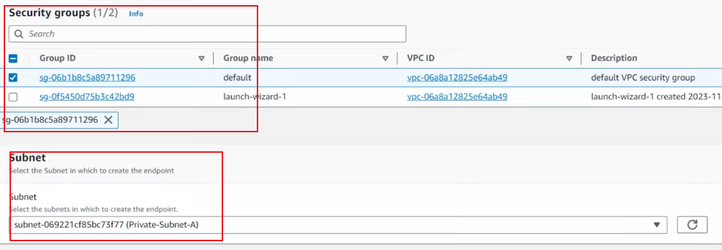
Select security group created and subnet eg. private-subnet-A and click create endpoint
And Access instance A . go to instance and select A-server
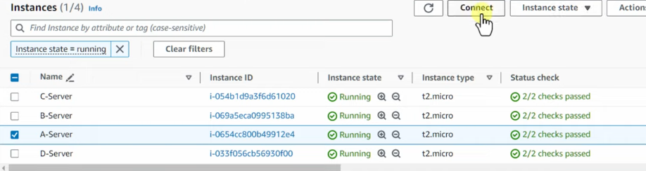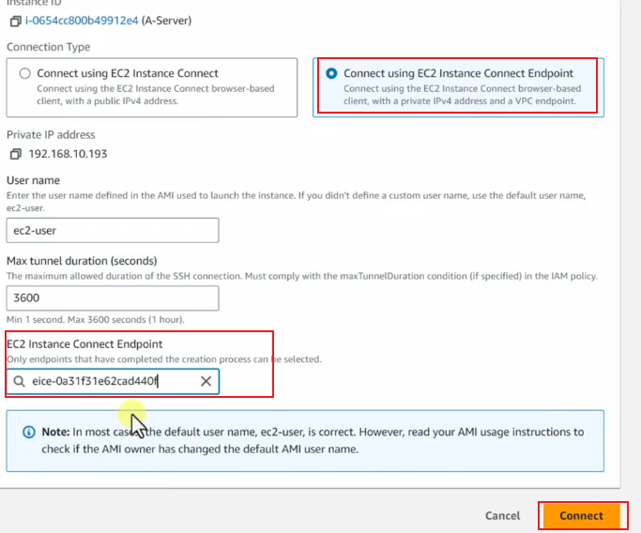
Select connect using ec2 instance connect endpoint and select created endpoint id and click connect
# Now connect multiple vpc’s using Transit Gateway.
Go to vpc dashboard and Transit Gateway and click create transit gateway
Give name TG-cloudfolks
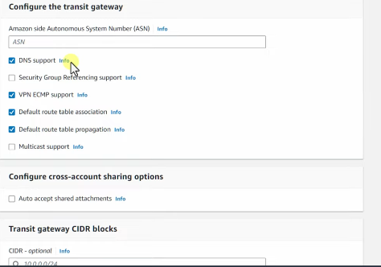 leave as it is.
Now click create transit gateway 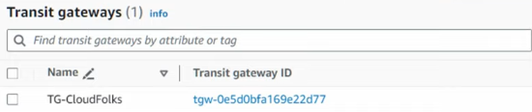 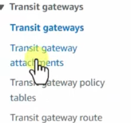 click transit gateway attchments. And click create transit gateway
attachment 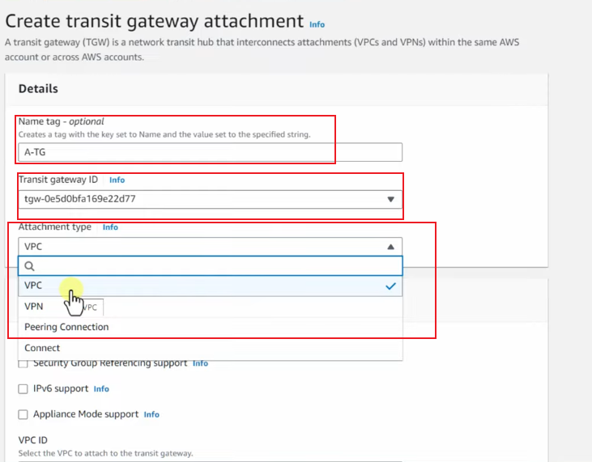
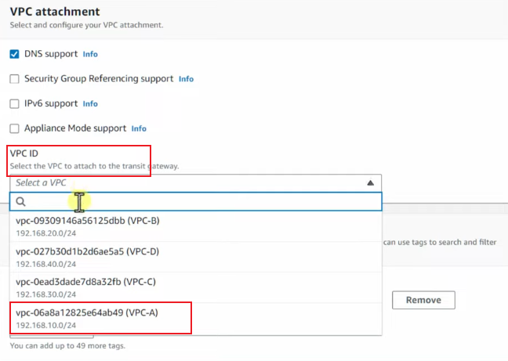 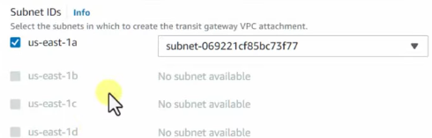 now click create trnasit gateway attachment button
# Now same for vpc B : 1-name: B-TG. 2->tg id(TG Cloudfolks) . 3>Attachment type : vpc
4> vpc id : (vpcB ) . 5> subnet id: selected by default 1 (As we’ve created only one subnet) then click create T.G
Same for vpc-c and vpc-D. Note transit id and vpc id of that vpc’s
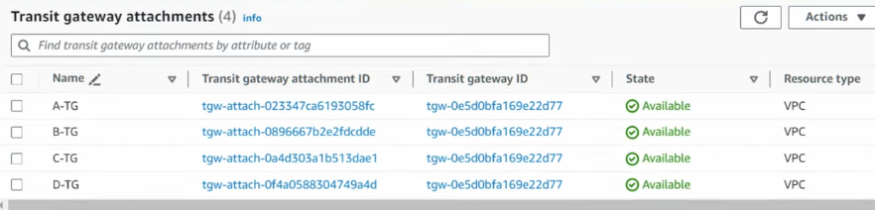
# Rout Table Entry: go to vpc’s route table. Select default vpc-a route table > go to route > edit route
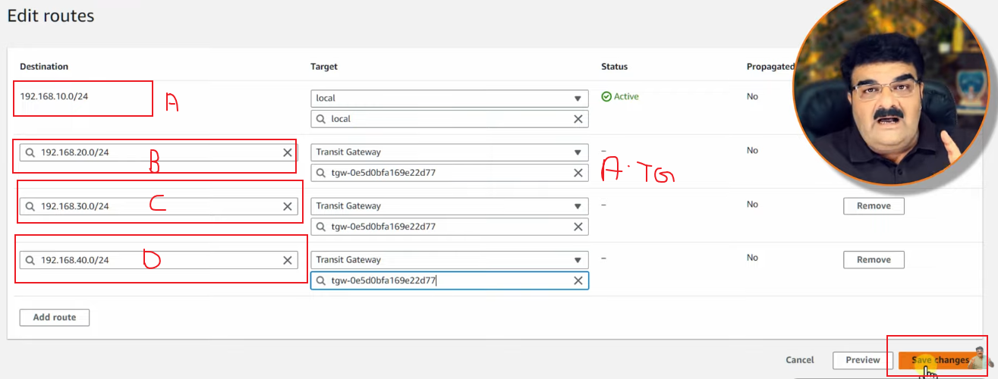
# Now Select vpc –B route table > route > Edit route
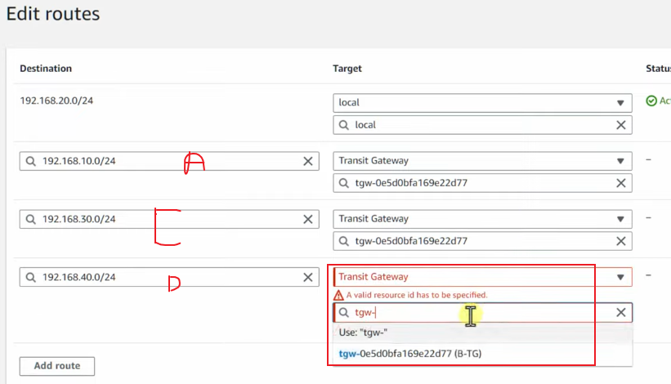
# now select vpc-c and repeate process as given above diagram select id for a,b,d , and transit gateway >C-TG. and vpc-D repeate and for a,b,c and transit gateway >D-TG
# Go to server-a console and ping 192.168.20.0/24 (select server-b private ip ) get communicated with b and for c and d server private ip also and check the connection

